**STT 810**

**ICA 4**

1. A very wobbly 4-sided die is used in a particular game. For this die, the pmf is given by



1. What is the cdf for this die?

Ans.

|  |  |
| --- | --- |
| X | CDF(X) |
| 1 | 0.3 |
| 2 | 0.5 |
| 3 | 0.65 |
| 4 | 1 |

1. If the die is rolled twice, what is the probability of the sum being a 4?

Ans. Total possible outcomes – 16 , Feasible option - 4

Probability psum(4) = 4/16 = 25%

1. A fair coin is flipped 12 times.
   1. What is the probability that the coin is heads exactly half of the time?

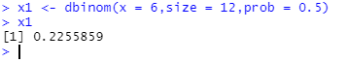

* 1. What is the probability that the coin is heads 3 times or less?

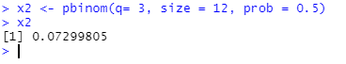

* 1. Perform a simulation of this coin flip in R. (1 simulation of 12 coin flips)

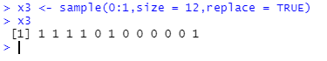

1. In a certain game, a player has a 20% chance of winning.
   1. If the player plays the game 6 times, what is the probability of winning at least twice?

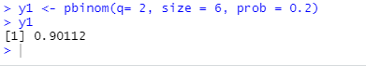

* 1. What is the probability on winning zero out of 6 times?

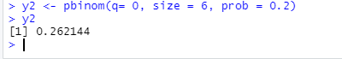

* 1. Perform 1,000 simulations of playing the game 6 times. How does the proportion in the simulation of getting a zero compare to your answer for b?

